SKIN GENIE

A PROJECT REPORT BY

# PRANAV KASHYAP (E23CSEU0894)

# MITALI BISHT (E23CSEU0783)



SUBMITTED TO

SCHOOL OF COMPUTER SCIENCE ENGINEERING AND TECHNOLOGY, BENNETT UNIVERSITY

GREATER NOIDA, 201310, UTTAR PRADESH, INDIA

April 2025

# DECLARATION

I/We hereby declare that the work which is being presented in the report entitled “Bennett Foods: Order, Grab, Enjoy!” is an authentic record of my/our own work carried out during the period from January 2023 to April 2025 at the School of Computer Science and Engineering and Technology, Bennett University, Greater Noida.

The matters and results presented in this report have not been submitted by me/us for the award of any other degree elsewhere.

**PRANAV KASHYAP**

(ENROLL. NO. E23CSEU0894)

**MITALI BISHT**

(ENROLL. NO. E23CSEU0783)

# ACKNOWLEDGEMENT

We would like to express my/our deepest gratitude to our mentor, **Dr. YAJNASENI DASH** ,for guiding, supporting, and assisting me/us at every stage of the project. I/We were extremely fortunate to have had him/her as my/our mentor, as his/her insightful solutions to problems faced by me/us contributed immensely to the completion of this project.

We would also like to thank the faculty members, my friends, and everyone who helped in making this project a success.

**PRANAV KASHYAP**

(ENROLL. NO. E23CSEU0894)

**MITALI BISHT**

(ENROLL. NO. E23CSEU0783)

## TABLE OF CONTENTS

LIST OF TABLES ......................................................................... **Error! Bookmark not defined.**

LIST OF FIGURES ....................................................................... **Error! Bookmark not defined.** LIST OF ABBREVIATIONS ........................................................ **Error! Bookmark not defined.**

ABSTRACT ................................................................................................................................... vi

1. INTRODUCTION ...................................................................................................................... 1
   1. Problem Statement ............................................................................................................... 1
2. Background Research ................................................................................................................. 3
   1. Proposed System ................................................................. **Error! Bookmark not defined.**
   2. Goals and Objectives ............................................................................................................ 4
3. Project Planning .......................................................................................................................... 5
   1. Project Lifecycle .................................................................................................................. 5
   2. Project Setup ....................................................................... **Error! Bookmark not defined.**
   3. Project Resources ................................................................................................................. 6
   4. Assumptions ......................................................................................................................... 6
4. Project Tracking .......................................................................................................................... 6
   1. Tracking .............................................................................. **Error! Bookmark not defined.** 4.2. Communication Plan ........................................................... **Error! Bookmark not defined.**

4.3. Deliverables ......................................................................... **Error! Bookmark not defined.**

1. SYSTEM ANALYSIS AND DESIGN ....................................................................................... 9
   1. Overall Description .............................................................................................................. 9
   2. Users and Roles .................................................................................................................... 9
   3. Design diagrams/ UML diagrams/ Flow Charts/ E-R diagrams ........................................ 11

5.3.1. Use Case Diagrams ...................................................................................................... 16 5.3.2. Class Diagram .............................................................. **Error! Bookmark not defined.**

5.3.3. Activity Diagrams ........................................................ **Error! Bookmark not defined.**

1. User Interface ............................................................................................................................ 18
   1. UI Description .................................................................................................................... 18
   2. UI Mockup ......................................................................................................................... 19
2. Algorithms/Pseudo Code .......................................................................................................... 25
3. Project Closure .......................................................................................................................... 27
   1. Goals / Vision ..................................................................................................................... 27
   2. Delivered Solution .............................................................................................................. 28
   3. Remaining Work ................................................................................................................ 29

REFERENCES .............................................................................. **Error! Bookmark not defined.**

## ABSTRACT

This Skin Genie is an AI-based platform that is fundamentally changing personal skincare with personalized recommendations based on individual skin types, concerns, and goals. Skin Genie uses advanced machine learning models and other computer vision techniques to analyze useruploaded images and survey inputs to assess skin conditions such as dryness, acne, sensitivity, and pigmentation. The program will therefore suggest personalized skincare regimes, products, and lifestyle tips that will help to heal and rejuvenate the skin. The project aims to democratize the findings of dermatology-making them affordable and scalable-so end-users can make sound decisions about their skin care. Future growth will include increasing diversity by building out the data set, integrating real-time skin tracking, and engaging dermatologists to further drive greater accuracy into recommendations.

The system will be tested on the Bennett University campus, and the results will inform future improvements. The core objective is to create a scalable solution that can be expanded to other campuses.

# 1. INTRODUCTION

1.1 In this present day, skin care has become a vital part of personal wellness and self-care. Due to this ever-changing world that seems to offer dozens of products, treatments, and advice, individuals have found it really hard to find solutions that match their particular skin problems. Skin Genie fits right in by providing a smart AI-enabled platform that gives personalized skincare recommendations with great precision and ease.

Skin Genie analyzes images of the user's skin in conjunction with inputs regarding their lifestyle using the principles of computer vision, machine learning, and dermatological knowledge. The system assesses important skin attributes like hydration levels, acne presence, sensitivity, or uneven tone and creates personalized skincare routines and product recommendations through which users confidently and consciously make the best choices. Skin Genie, furthermore, seeks to democratize personalized skincare guidance for anyone with a smartphone.

As evolution is on with the system, Skin Genie wants to be able to provide an even wider range of skin types, real-time tracking for monitoring progress, and improved collaboration with skincare professionals, thus really raising the bar for smart skincare solutions.

## Problem Statement

Currently, students and faculty spend a significant amount of time waiting in long queues at food stalls on campus. The inefficiency of this process not only wastes time but also leads to user dissatisfaction. *Bennett Foods* aims to address these problems by providing an easy-to-use, fast, and efficient way for users to place food orders, receive real-time updates, and reduce overall wait time at food stalls.

# 2. BACKGROUND RESEARCH

The skincare sector has witnessed a vigorous growth in the last decade as consumer consciousness and demand for personalized solutions have risen. For the most part, however, most skincare recommendations are based on broad categories like "oily" or "dry" or "sensitive," which fail to acknowledge the diverse and dynamic nature of individual skin conditions. Furthermore, dermatological consultations are costly and often inadequate for a huge section of the population.

Starting with the recent advances in machine learning, particularly in image processing and computer vision, the high-precision analysis of skin conditions has opened exciting windows. Studies have proven CNNs capable of distinguishing skin problems, including acne, wrinkles, and pigmentation, through images. Such recommender systems have been used extensively in domains like e-commerce and entertainment by providing users with customized suggestions based on tastes and behaviors. Employing similar techniques in skincare can propel personalization to another level.

Current solutions like the AI skincare apps tend to provide only superficial evaluations lacking any accuracy and depth that can be truly useful for customized advice. The problems of training datasets being biased due to substantial underrepresentation of diverse skin tones and a limited range of the lifestyle factors on which the system works (diet, environment, stress, etc.) linger on.

Skin Genie aims to build on the technology to offer a more inclusive, specific, and userfriendly platform that analyzes the skin condition and modifies these recommendations by continual user feedback and input.

## 2.1 Goals and Objectives

**Mission**

**Skin Genie is on a mission to develop an intelligent, easily accessible platform that delivers highly personalized skincare recommendations based on the accurate assessment of individual skin conditions.**

**Specific Aims:**

**Skin Analysis: Development and training of a machine-learning model that will analyze skin images uploaded by users, for detecting conditions like dryness, acne, sensitivity, pigmentation, and other concerns.**

**Personalized Recommendations: Development of a recommendation engine for suggesting skin care routines, products, and lifestyle changes, tailored to the user's skin type and skin concerns.**

**User-Friendly Interface: Design a simple yet charming and functional mobile or web application for the user to effortlessly upload images, put in lifestyle information, and receive recommendations.**

**Inclusivity: There will be a data diversity criterion in training the AI model, representing different skin tones, ages, and conditions, to make the AI unbiased and provide fair results.**

**Progress Tracking: The expected feature will allow users to track changes in skin condition over time and adjust recommendations dynamically based on feedback and new inputs.**

**Expert Collaboration: This will lay the groundwork for cooperation with dermatologists to validate AI results and enhance the quality of advice.**

**Scalability: The system must be able to scale efficiently to a larger number of users, while also retaining strong data privacy and security principles.**

# 3. PROJECT PLANNING

## *3.1 Project Lifecycle*

We followed an Agile development methodology with weekly sprints focused on individual features. These included UI/UX development, AI model integration, image preprocessing, prescription module, and final testing. Regular feedback loops ensured adaptability and continuous improvement.

## *3.2 Project Setup*

The project setup involved configuring React and TypeScript for the frontend, setting up Tailwind CSS for styling, and integrating TensorFlow.js for AI processing. The model was trained using the HAM10000 dataset, and product data was manually curated to offer tailored recommendations.

**3.3 Project Resources**

|  |  |  |
| --- | --- | --- |
| **Resource** | **Resource Description** | **Quantity** |
| FRONTEND | TailwindCSS | 1 |
| Developers | Team members working on the frontend and backend | 2 |
| DATASET | HAM10000 | 1 |

**3.4 Assumptions**

|  |  |
| --- | --- |
| **#** | **Assumption** |
| **A1** | Users have camera-enabled devices. |
| **A2** | Users are comfortable using a web application. |
| **A3** | The AI system is not a substitute for medical advice but a supportive tool. |

# 4. PROJECT TRACKING

## 4.1. Tracking

In this section, we describe the tools and systems used to track the progress of the **SKIN GENIE**  project. These include the source control system, bug tracking, and regression testing, along with the relevant links to access each resource.

|  |  |
| --- | --- |
| **Information** | **Description** |
| **Code Storage** | Project code is stored in a GitHub repository for version control. |
| **Bug Tracking** | Bug tracking will be done using GitHub Issues for tracking bugs. |
| **Project Documents and Assignments** | Weekly reports, design documents, and other project-related files are stored in the GitHub repository. |
| **Continuous Integration** | Continuous integration will be done with GitHub Actions for automated testing and deployment. |
| **Regression Testing** | Regression testing will be done using Jest for unit tests, integrated with GitHub Actions for automation.  **4.2. Communication Plan**  **Regularly Scheduled Meetings** |
| **Meeting Type** | **Frequency/Schedule Who Attends** |
| **Team Meeting** | Weekly Project team |
| **Short Meeting** | Weekly in class Project team |

**Sprint Planning Meeting** Start of each sprint Project team and mentor **Sprint Review Meeting** End of each sprint Project team, mentor



## 4.3. Deliverables

The following deliverables are expected as part of the **SKIN GENIE** project. These deliverables represent all the key components and outcomes of the project.

### Deliverables

Deliverables

Machine Learning Model for Skin Analysis:

A trained and validated AI model capable of detecting common skin conditions from useruploaded images with high accuracy. Personalized Recommendation Engine:

A system that generates customized skincare routines and product suggestions based on skin analysis results and user inputs (like lifestyle factors).

User Application: Mobile/Web:

An easy-to-use interface for users that allows them to upload pictures, fill out surveys, view skin reports, and receive recommendations.

Progress Tracking:

A feature that enables users to track the changes occurring in their skin condition with time and new recommendations based on it.

Diverse and Inclusive Dataset:

A nurtured dataset with diversity in skin tones, age, and type, to guarantee fairness and decrease bias in AI predictions.

Documentation and User Manual:

All-encompassing technical documentation regarding system architecture, model training, and usage; plus, a simple yet detailed manual on using the app itself.

Privacy and Security Protocols:

Implementation of data protection measures should ensure user data (in particular images) will be stored and handled securely.

Research Report/Presentation:

Completion report or presentation that captures the key objectives, methodology, challenges, results, and recommendations for future work.

## 5 SYSTEM ANALYSIS AND DESIGN

### 5.1 Overall Description

The *Bennett Foods* platform is designed to provide students and faculty with an easy-touse, efficient food ordering and pickup system that reduces the time spent in long queues at campus food stalls. The system allows users to place food orders via a mobile app or web interface, choose their items, and pay in advance. Once the order is placed, the user receives an OTP (One-Time Password) on their phone, which they will use to collect their food when it is ready. This OTP verification helps reduce wait times, streamline the order process, and ensures secure pickup without the need for physical interaction at the food stall.

The system’s backend is powered by Firebase for real-time synchronization of data and ensures that users' order statuses are updated instantly. The frontend is developed using React.js for a smooth user interface experience, providing quick navigation, order tracking, and notifications. By implementing this solution, the project aims to optimize the campus food ordering system, improving overall satisfaction for both vendors and customers. The platform can scale to other campuses with minimal additional configuration.

### 5.2 Users and Roles

Skin Genie: AI for skin condition-based personalized recommendations. The project uses state-of-the-art machine learning methods that include computer vision and natural language processing to assess a user's skin based on visual factors (that include skin images) and lifestyle data. As such, the custom skincare routines given to the user would evolve based on real-time feedback and product suggestions and lifestyle information to ensure the user is always getting a solution that suits their changing needs.

Skin Genie integrates analyzing user-uploaded skin images using a trained deep-learning model as its core functionality. The deep-learning model recognizes important features (such as acne, pigmentation, wrinkles, or dryness) and converts this information into a recommendation for a bespoke skincare regimen. Consequently, the platform accounts for lifestyle factors, including diet, sleep, and environmental conditions, resulting in further refinement of recommendations.

The system has a simple interface to interact with the user, whereby the users can keep an easy track of their skincare journey, upload images for periodic analysis, and see their skin health changes over time. Skin Genie also strives for inclusiveness, ensuring that the model gets trained on diverse datasets, accounting for varying skin tones, skin textures, and skin conditions.

Skin Genie envisions that all skincare advice are now within everybody's reach-a vision targeting global users with affordable, unshakeable, personalized solutions to make their life toward healthier skin.

**5.3 Design diagrams/Architecture/ UML diagrams/ Flow Charts/**

### E-R diagrams

**5.3.1 Product Backlog Items**

Product Backlog Items

Registration and Profile Creation for Users

Allow creation of accounts and management of user profiles.

Collect primary skin information (age, skin type, concerns) during the initial registration.

Image upload and analysis of the skin

Develop a facility where users can upload images of their skin.

Import a machine learning model for automatic analysis of the skin condition for features such as acne, dryness, pigmentation, etc.

Personalized recommendations for skin care

Create a recommendation engine for skin care routines based on the user analysis of the skin.

Personal recommendations for products such as moisturizers, cleansers and serums.

Lifestyle Survey

Conduct a survey to collect lifestyle factors (diet, sleep patterns, environmental factors) that may influence skin health.

Feed all this data into the skincare recommendation engine.

Progress Tracking

Allow users to record changes for their skin over time.

Give users an option to upload photos they have made changes to and have them update their recommendations accordingly.

User Feedback System

Put in a feedback loop for advising skincare recommendations which changes according to the experience and progress of the user.

Dataset for Diverse Skin Tones and Conditions

Gather and curate a widely diverse dataset for training the machine learning model for it to be able to perfectly analyze different skin tones, types and conditions.

Data Privacy Solutions and Security Measures

Creation of a stronghold system for the safety of user data, primarily image sensitive.

Implementation of data anonymization and secure storage procedures.

UI/UX Design for User App

An engaging, compelling and easy to navigate user interface for easy usage in both mobile and web platforms.

Accessibility features such as text resizing, high contrasting options, etc.

Integration with Dermatologists for Expert Feedback

Partnership with dermatologists to validate the recommendations of the platform and outputs from the model.

Guidance from the experts will also go in the user guidance.

Multi-language Support

The platform will allow various languages to meet global users.

Automated Reports and Recommendations Adaptation

An automated system should be created that automatically updates skincare routines as per the new skin analysis results or user feedback.

User Engagement and Notification System

A system to remind users about the upload of new images, checking their progress or fulfilling their lifestyle survey.

Analytics Dashboard (Admin)

This will allow the administration to create an entire new dashboard to monitor users' interaction and applications that measure model performance.

Provide angles to trends of users and skin health patterns.

Beta Testing and User Feedback Collection

Open the app for beta testing and collect users' views about the ease of use and recommendations.

This should then be fed back through the necessary iterations into the product.

**5.3.2 Architecture Diagram**

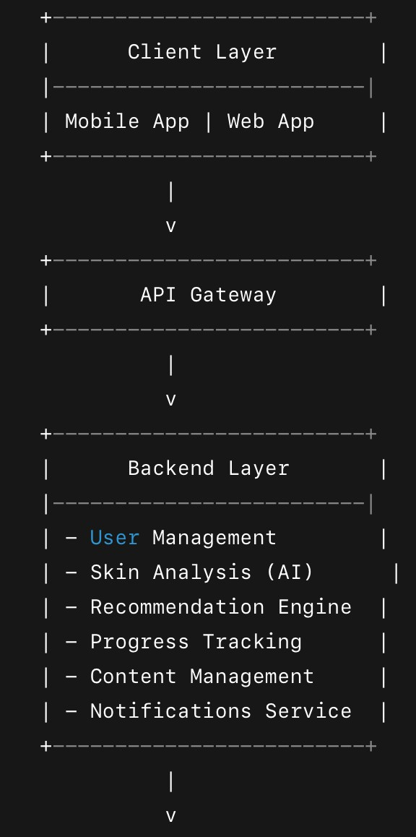

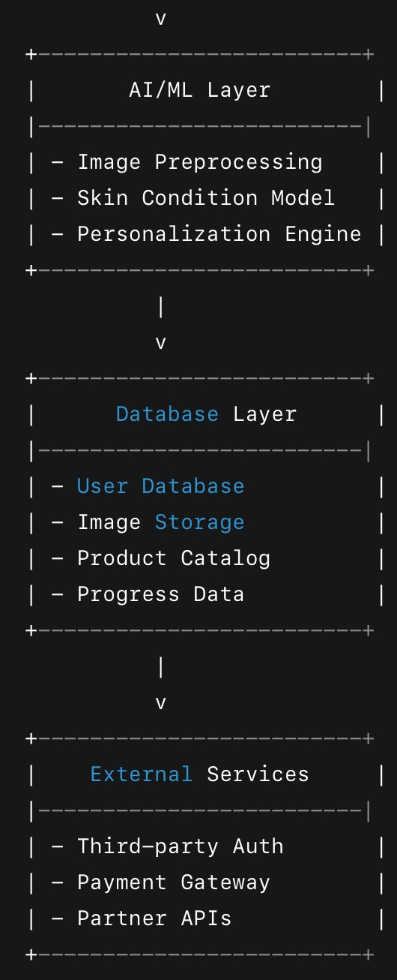

**5.3.3 Use Case Diagram**

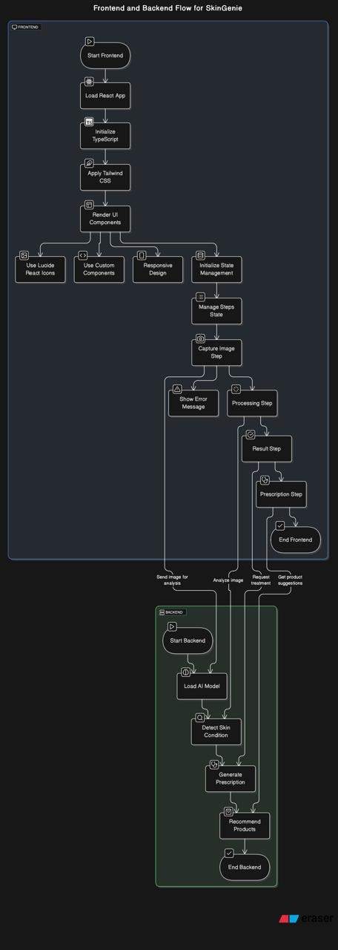

## 6 USER INTERFACE

### 6.1 UI Description

The interface's set-of-features:

Welcome and Onboarding

Skin Genie is introduced in this welcome screen, following which the user is given the option to either sign up or log in.

The onboarding process will assist users with their profile setup, which includes collecting basic information (age, skin type, skin concerns) and the method of getting an accurate picture of their skin.

Dashboard/Home Screen

Post-login, users would be taken to their dashboard, where they could review an overview of their skincare routine, their last skin analysis, and any updates on progress.

Users could easily navigate their way through skin image uploads, recommendations, progress tracker, and lifestyle survey.

Image Upload and Skin Analysis

An easy and straightforward photo upload interface for the user's skin. The UI will guide the user on how to take good-quality images to achieve better analysis.

A progress bar or animation will display the image analysis process.

Once the analysis has reached completion, the results will appear in a clean format that is easy to read, highlighting skin concerns identified in the photos (e.g., acne, pigmentation, wrinkles).

Personalized Skincare Recommendations

This is a dedicated page users can go to view their personalized skincare routine and product suggestions.

The page would include extensive information about the recommended product, including how and when to system and why it suits the user’s skin type and skin condition.

There is also an option to mark as tried or save for later.

### 6.2 UI Mockup

Attach the screenshot of user interface. This can be a simple drawing that demonstrates key parts of the user interface

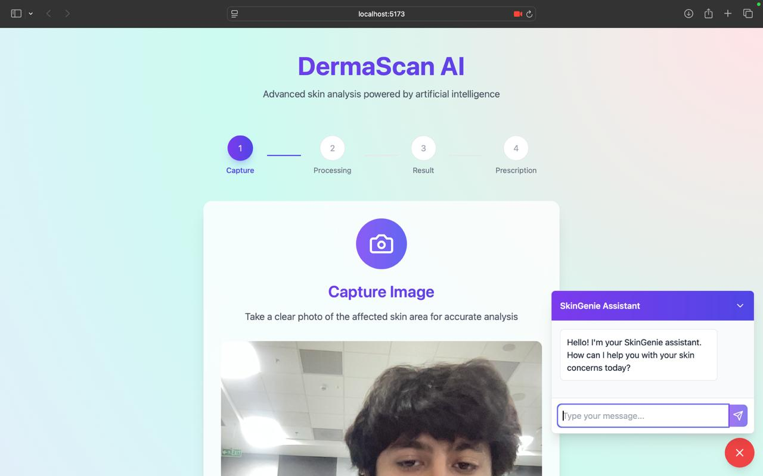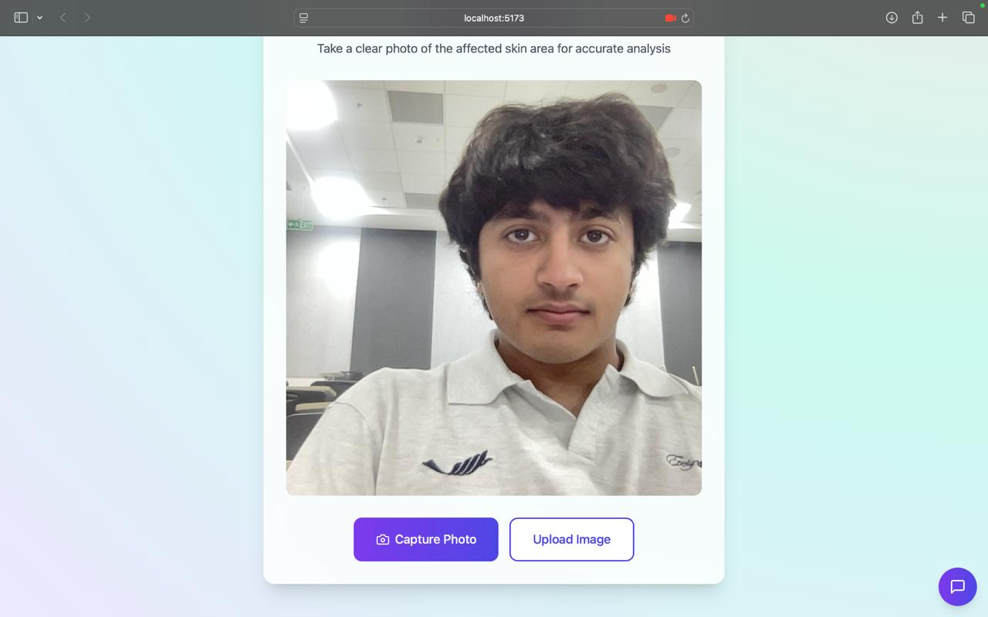

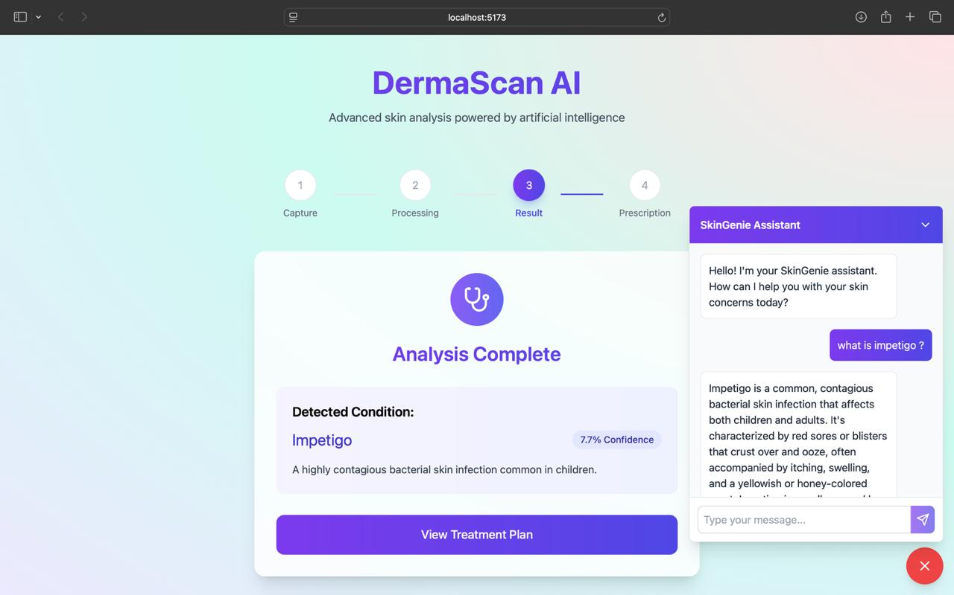 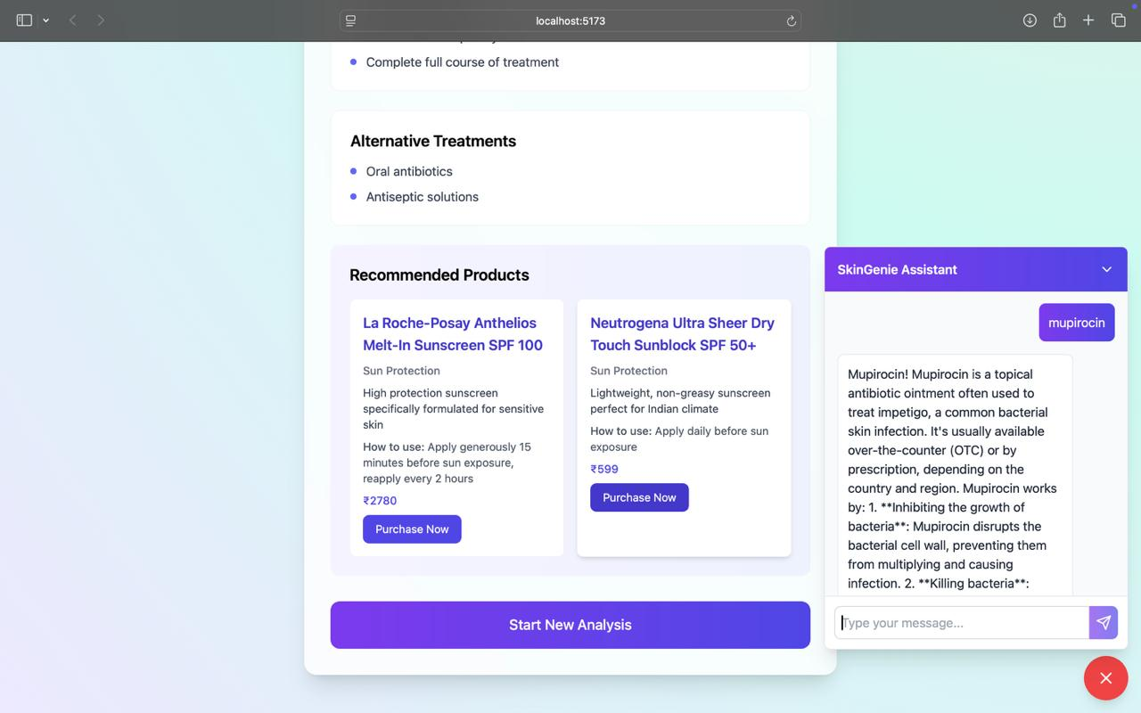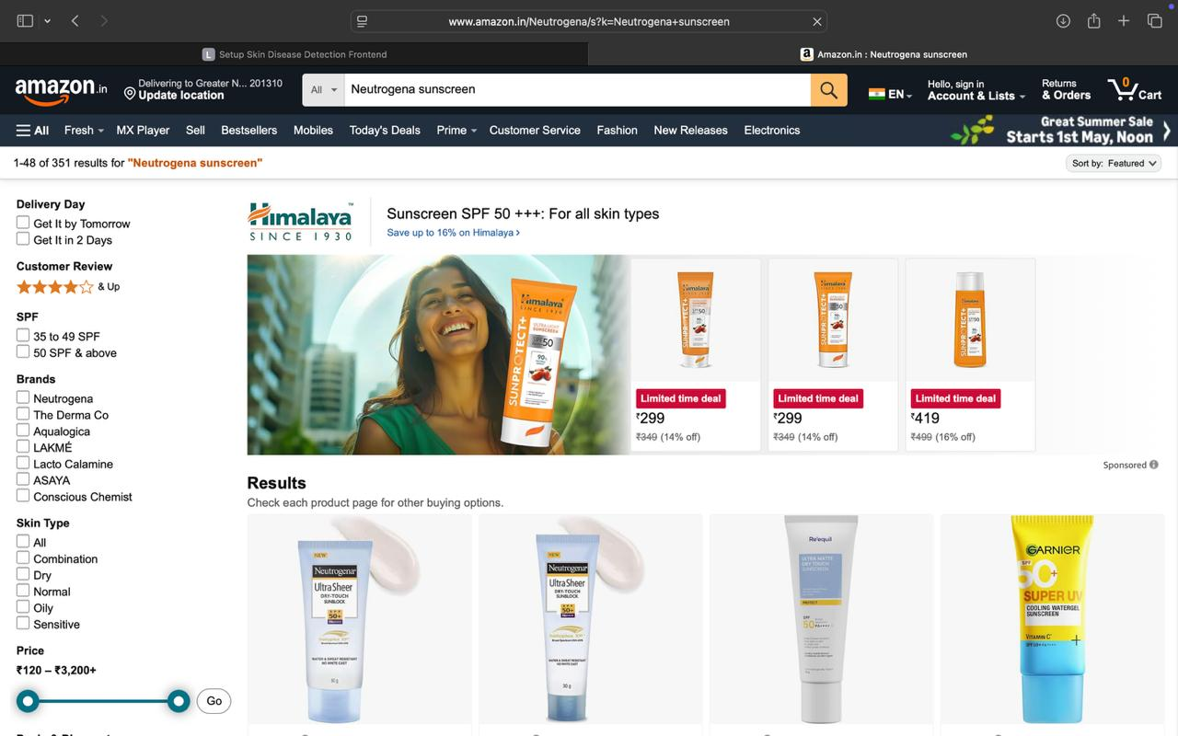

## 7 ALGORITHMS/PSEUDO CODE OF CORE FUNCTIONALITY

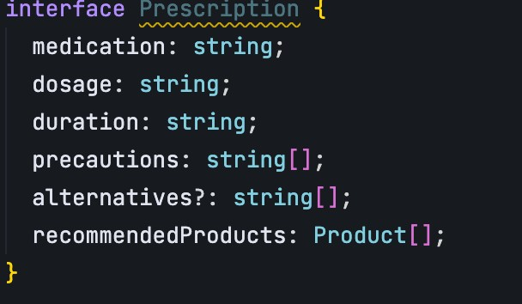

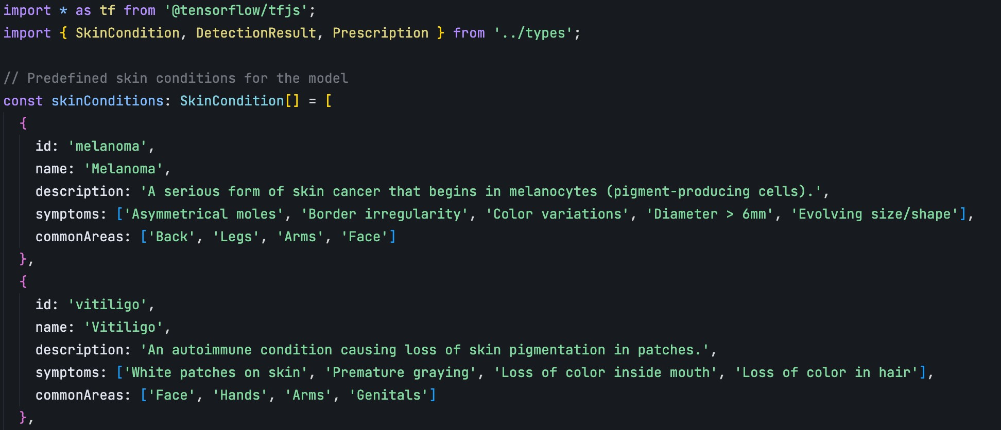

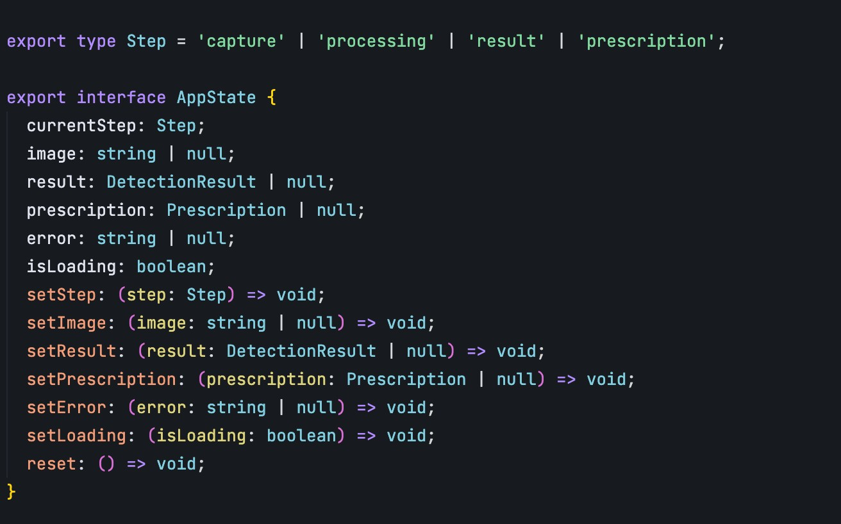

## 8 PROJECT CLOSURE

### 8.1 Goals / Vision

Vision:

Skin Genie envisions a world where everyone has access to personalized skincare advice that is both effective and affordable. Skin Genie seeks democratization of dermatological insights and skin health empowerment among individuals by way of artificial intelligence and machine learning. A long-term vision will be creating a global platform that will not just cater to personalized skin care routines but also evolve with the user, continuously adaptive in fostering healthy, radiant skin.

Goals:

Personalization at Scale:

Developing a sophisticated AI program capable of analyzing diverse skin conditions and offering personalized skin care finds for millions of users regardless of geography, skin type, or budget.

Accessibility and Affordability:

Tangible international research on affordable skincare advice backed by experts to reach users worldwide and make it available for those who do not have resources for personalized dermatological care.

Continuous Improvement:

Keeping updating the AI model of the platform with user feedback, dermatologist outreach activity, and ongoing research to ensure ever-accurate and relevant recommendations.

Inclusivity:

There should be no biases in the solutions offered to people from all walks of life. Thus, this platform would cater to all user types, i.e., skin tone, age, and condition.

### 8.2 Delivered Solution

Skin Genie is essentially an all-around skincare platform driven by AI. It touches on several areas that users face in achieving the desired glow and health on their skin. The solutions delivered thus far combine cutting-edge machine-learning algorithms, personalized recommendations, and an intuitive user interface.

AI Skin Analysis

Solution: A potent machine-learning model is embedded in the platform to analyze images uploaded by users in order to detect common skin concerns such as acne, dryness, pigmentation, and wrinkles. This purely automatic analysis gives real-time assessments of the skin conditions for users.

Impact: The users are now able to gain instant data-backed insight into the health of their skin without consulting a therapist, which has made such expert-level skin care suggestions available for all.

Personalized Skincare Recommendations

Solution: Skin Genie provides customized skincare routines depending on the skin analysis results obtained for the individual. The platform recommends products - from cleansers to serums - specifically suited to the user in specifications and preferences.

Impact: This level of personalization affords users the ability to choose products that are likely to work for their skin, minimizing the trial-and-error path and increasing the chances of positive results.

### 8.3 Remaining Work

While *Skin Genie* has made significant progress in delivering key features and solutions, there are still several important tasks and enhancements required to ensure the platform’s success, scalability, and user satisfaction. The remaining work includes:

1. **Model Refinement and Expansion** o **Task:** Continuously improve the AI model by expanding its training dataset, ensuring better accuracy and inclusivity, and refining its ability to detect subtle skin conditions. o **Impact:** This will help the platform provide even more accurate and comprehensive skin analyses for a wider range of skin types and conditions.
2. **Integration of Dermatologist Reviews** o **Task:** Establish partnerships with dermatologists to validate the platform’s skin analysis results and product recommendations.
   * **Impact:** This will enhance the credibility of the platform and allow expert insights to be incorporated, leading to more reliable advice for users.
3. **Advanced Lifestyle Integration** o **Task:** Enhance the lifestyle survey by integrating more dynamic factors, such as geographic location (climate, pollution), stress levels, and other real-time data inputs.
   * **Impact:** A more comprehensive understanding of user behavior will further personalize skincare routines, improving overall results and user satisfaction.
4. **Multi-language and Globalization Support** o **Task:** Extend the platform’s language options and regional customization (including different skincare concerns based on geography). o **Impact:** This will enable Skin Genie to cater to a broader global audience, ensuring that language barriers and regional skin concerns are addressed.
5. **User Engagement Features** o **Task:** Implement features that increase user engagement, such as gamification elements (e.g., progress badges, milestones) and social sharing options.
   * **Impact:** These features will help increase retention and make the app more interactive, encouraging users to keep up with their skincare routines.
6. **Subscription and Monetization Strategy** o **Task:** Develop and implement a subscription model or a freemium system that provides additional premium services, like advanced dermatologist consultations, exclusive products, or personalized product kits. o **Impact:** This will allow the platform to generate revenue while still providing valuable free features to all users.
7. **Testing and Quality Assurance** o **Task:** Perform extensive testing to ensure the app runs smoothly across all devices and platforms, especially focusing on the mobile app for seamless functionality.
   * **Impact:** This will guarantee that users experience a bug-free, reliable service, fostering trust in the platform.
8. **Expansion of Skincare Product Partnerships**
   * **Task:** Form additional partnerships with skincare brands to expand the range of product recommendations available on the platform, ensuring that users have access to a diverse set of options.
   * **Impact:** A larger variety of recommended products will improve user satisfaction by catering to various price points, product preferences, and skin conditions.
9. **User Feedback and Iterative Improvements** o **Task:** Continue collecting and analyzing user feedback to refine and enhance features based on real-world use and experiences. o **Impact:** This will ensure that the platform evolves in line with user needs and market trends, fostering long-term engagement and satisfaction.
10. **Marketing and User Acquisition** o **Task:** Develop a comprehensive marketing strategy to attract new users to the platform, utilizing digital marketing channels, influencer partnerships, and content marketing. o **Impact:** This will drive user growth, increasing the platform’s reach and making *Skin Genie* a well-known name in personalized skincare.